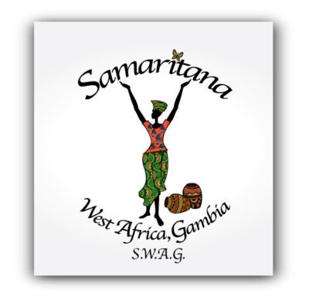
Info@samaritanagambia.com Ph +220 229 6733/750 6328 whatsap

Samaritana, as a Gambian controlled, & led ministry,shows acts of love towards the people of The Gambia by…. In alphabetical order

1 BRA’s: We supply bra’s and other free items to survivors of sexual abuse, to their mothers and sisters too, and to girls and women in Bakau.

2 COURT WORK: We accompany survivors and witnesses to court, everytime they are due to appear, as well as when doctors appear.

3 EVIDENCE: We rescue repeatedly lost case evidence, monitor it, so it gets safely into & out of the Prosecution office, we continue this through the AG’s office too.

4 FOODSTUFFS: We redistribute Free foodstuffs given to us, passing any balance onto Hart House (for children with physical and intellectual disabilities).

5 KITS: We make Recyclable Sanitary Kits for girls (Occupational Therapy) which are given away at D50, (nzd$2) The kits last 3 years & survivors are paid to make them

6 LIBRARY: We run a Free Community Library for children & adults to use for study and reading. We allow a local to run specialist English classes there as well.

7 MICRO-ENTERPRISE FUND: Is available to all team members and their families so as to broaden their skills basis and provide for their schooling.

8 POLICE: We take referrals from Police HQ and follow up some victims and monitor their cases as well as the offenders behaviour if they are not in prison.

9 SCHOOLS: We do a 3 week School Presentation focusing on Good+Bad Touch, Relationships, Bumsters/Prostitution & Menstralation. Our Annon ? Box uncovers abuse

10 SPONSORS: We act as agents for tourists who ask us to ensure their sponsorship money gets to the family and child they are sponsoring.

11 SHELTER: We shelter sexual abuse survivors, up to 10 children in at any one time. Our shelter is under the guidance of the DSW.

12 SURVIVORS: We do long term rehab ministry with survivors in Group Therapy (Art, Physical, Puppet Work, Dancing, Drama etc) as well as individual mentoring.

13 We pray for the victims and survivors and their families. We do not proselytise

